Pascal's Triangle

One of the most interesting Number Patterns is Pascal's Triangle (named after Blaise Pascal, a famous French Mathematician and Philosopher).
To build the triangle, start with "1" at the top, then continue placing numbers below it in a triangular pattern.
Each number is the numbers directly above it added together.
(Here I have highlighted that 1+3 = 4)

Patterns Within the Triangle

Diagonals
The first diagonal is, of course, just "1"s
The next diagonal has the Counting Numbers (1,2,3, etc).
The third diagonal has the triangular numbers
(The fourth diagonal, not highlighted, has the tetrahedral numbers.)

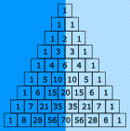

Symmetrical
The triangle is also symmetrical. The numbers on the left side have identical matching numbers on the right side, like a mirror image.

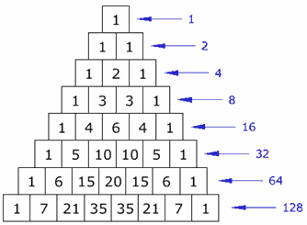

Horizontal Sums
What do you notice about the horizontal sums?
Is there a pattern?
They double each time (powers of 2).

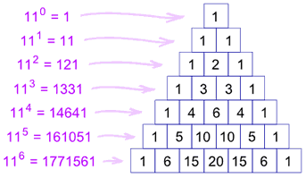

Exponents of 11
Each line is also the powers (exponents) of 11:
- 110=1 (the first line is just a "1")
- 111=11 (the second line is "1" and "1")
- 112=121 (the third line is "1", "2", "1")
- etc!
But what happens with 115 ? Simple! The digits just overlap, like this:
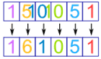
The same thing happens with 116 etc.

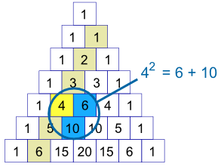

Squares
For the second diagonal, the square of a number is equal to the sum of the numbers next to it and below both of those.
Examples:
- 32 = 3 + 6 = 9,
- 42 = 6 + 10 = 16,
- 52 = 10 + 15 = 25,
- ...
There is a good reason, too ... can you think of it? (Hint: 42=6+10, 6=3+2+1, and 10=4+3+2+1)

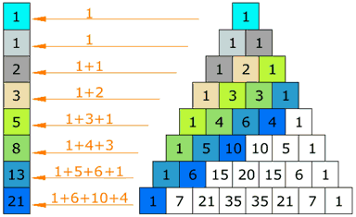

Fibonacci Sequence
Try this: make a pattern by going up and then along, then add up the values (as illustrated) ... you will get the Fibonacci Sequence.
(The Fibonacci Sequence starts "0, 1" and then continues by adding the two previous numbers, for example 3+5=8, then 5+8=13, etc)

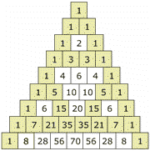

Odds and Evens
If you color the Odd and Even numbers, you end up with a pattern the same as the Sierpinski Triangle

Using Pascal's Triangle

Heads and Tails
Pascal's Triangle can show you how many ways heads and tails can combine. This can then show you the probability of any combination.
For example, if you toss a coin three times, there is only one combination that will give you three heads (HHH), but there are three that will give two heads and one tail (HHT, HTH, THH), also three that give one head and two tails (HTT, THT, TTH) and one for all Tails (TTT). This is the pattern "1,3,3,1" in Pascal's Triangle.
Tosses | Possible Results (Grouped) | Pascal's Triangle
1 | H  T | 1, 1
2 | HH  HT TH  TT | 1, 2, 1
3 | HHH  HHT, HTH, THH  HTT, THT, TTH  TTT | 1, 3, 3, 1
4 | HHHH  HHHT, HHTH, HTHH, THHH  HHTT, HTHT, HTTH, THHT, THTH, TTHH  HTTT, THTT, TTHT, TTTH  TTTT | 1, 4, 6, 4, 1
 | ... etc ...

Example: What is the probability of getting exactly two heads with 4 coin tosses?
There are 1+4+6+4+1 = 16 (or 24=16) possible results, and 6 of them give exactly two heads. So the probability is 6/16, or 37,5%

Combinations
The triangle also shows you how many Combinations of objects are possible.

Example: You have 16 pool balls. How many different ways could you choose just 3 of them (ignoring the order that you select them)?
Answer: go down to the start of row 16 (the top row is 0), and then along 3 places (the first place is 0) and the value there is your answer, 560.
Here is an extract at row 16:
1 14 91 364 ...
1 15 105 455 1365 ...
1 16 120 560 1820 4368 ...

A Formula for Any Entry in The Triangle
In fact there is a formula from Combinations for working out the value at any place in Pascal's triangle:
It is commonly called "n choose k" and written like this: |  | 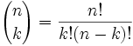
Notation: "n choose k" can also be written C(n,k), nCk or even nCk.
 | The "!" is "factorial" and means to multiply a series of descending natural numbers. Examples:  - 4! = 4 × 3 × 2 × 1 = 24  - 7! = 7 × 6 × 5 × 4 × 3 × 2 × 1 = 5040  - 1! = 1

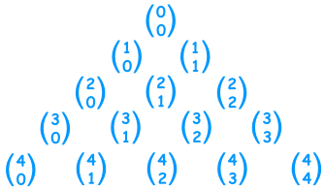
So Pascal's Triangle could also be
an "n choose k" triangle like this one.
(Note how the top row is row zero
and also the leftmost column is zero)

Example: Row 4, term 2 in Pascal's Triangle is "6" ...
... let's see if the formula works:
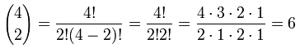
Yes, it works! Try another value for yourself.
This can be very useful ... you can now work out any value in Pascal's Triangle directly (without calculating the whole triangle above it).

Polynomials
Pascal's Triangle can also show you the coefficients in binomial expansion:
Power | Binomial Expansion | Pascal's Triangle
2 | (x + 1)2 = 1x2 + 2x + 1 | 1, 2, 1
3 | (x + 1)3 = 1x3 + 3x2 + 3x + 1 | 1, 3, 3, 1
4 | (x + 1)4 = 1x4 + 4x3 + 6x2 + 4x + 1 | 1, 4, 6, 4, 1
 | ... etc ...

The First 15 Lines
For reference, I have included row 0 to 14 of Pascal's Triangle
1
1
1
1
2
1
1
3
3
1
1
4
6
4
1
1
5
10
10
5
1
1
6
15
20
15
6
1
1
7
21
35
35
21
7
1
1
8
28
56
70
56
28
8
1
1
9
36
84
126
126
84
36
9
1
1
10
45
120
210
252
210
120
45
10
1
1
11
55
165
330
462
462
330
165
55
11
1
1
12
66
220
495
792
924
792
495
220
66
12
1
1
13
78
286
715
1287
1716
1716
1287
715
286
78
13
1
1
14
91
364
1001
2002
3003
3432
3003
2002
1001
364
91
14
1

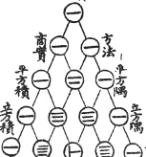

The Chinese Knew About It
This drawing is entitled "The Old Method Chart of the Seven Multiplying Squares". View Full Image
It is from the front of Chu Shi-Chieh's book "Ssu Yuan Yü Chien" (Precious Mirror of the Four Elements), written in AD 1303 (over 700 years ago, and more than 300 years before Pascal!), and in the book it says the triangle was known about more than two centuries before that.

The Quincunx
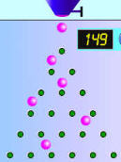
An amazing little machine created by Sir Francis Galton is a Pascal's Triangle made out of pegs. It is called The Quincunx.
Balls are dropped onto the first peg and then bounce down to the bottom of the triangle where they collect in little bins.
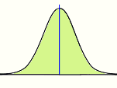
At first it looks completely random (and it is), but then you find the balls pile up in a nice pattern: the Normal Distribution.

Pascal's Triangle
Kate Berryman: Kate's 6690 Homepage
Primes  When you look at Pascal's Triangle, find the prime numbers that are the first number in the row. That prime number is a divisor of every number in that row. | 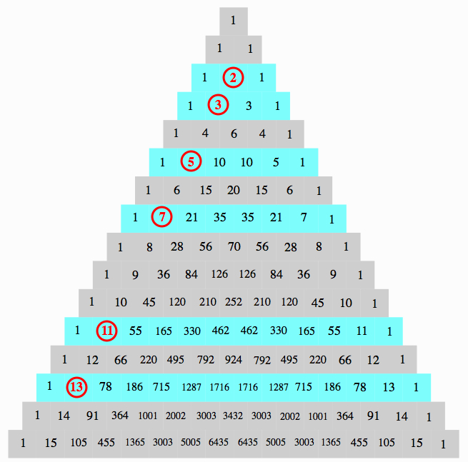
Powers of 2  Now let's take a look at powers of 2. If you notice, the sum of the numbers is Row 0 is 1 or 2^0. Similiarly, in Row 1, the sum of the numbers is 1+1 = 2 = 2^1. If you will look at each row down to row 15, you will see that this is true. In fact, if Pascal's triangle was expanded further past Row 15, you would see that the sum of the numbers of any nth row would equal to 2^n | 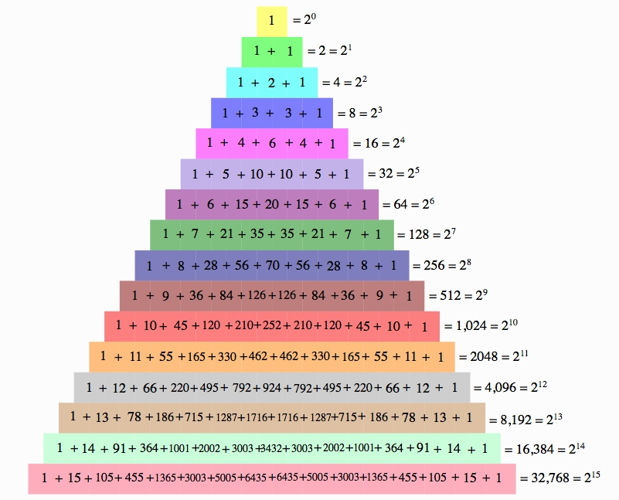
Magic 11's  Each row represent the numbers in the powers of 11 (carrying over the digit if it is not a single number). For example, the numbers in row 4 are 1, 4, 6, 4, and 1 and 11^4 is equal to 14,641. Look at row 5. The numbers in row 5 are 1, 5, 10, 10, 5, and 1. Since 10 has two digits, you have to carry over, so you would get 161,051 which is equal to 11^5. | 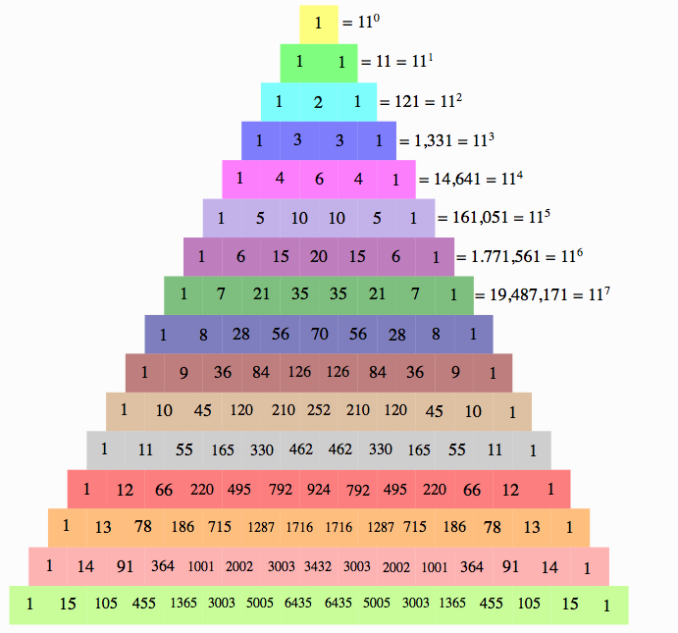
Hockey Stick Pattern  Start with any number in Pascal's Triangle and proceed down the diagonal. Then change the direction in the diagonal for the last number. That last number is the sum of every other number in the diagonal. | 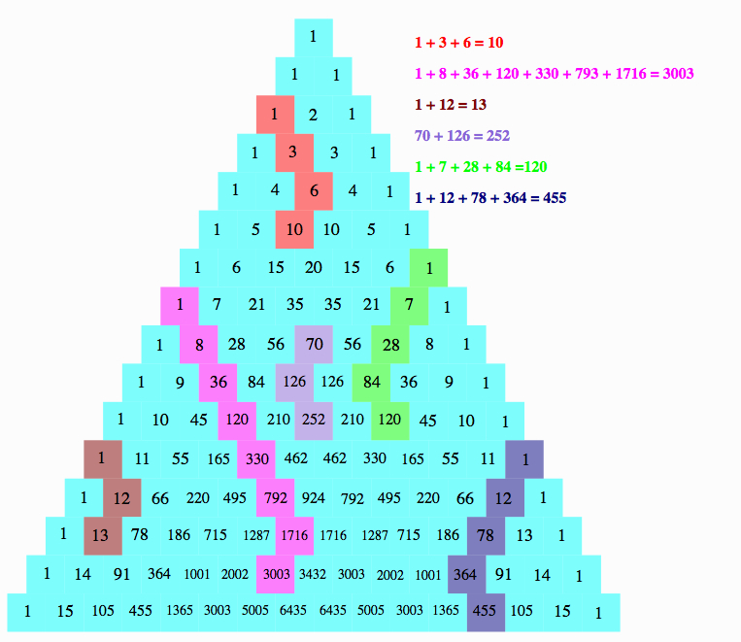
Triangular Numbers  If you start with row 2 and start with 1, the diagonal contains the triangular numbers. | 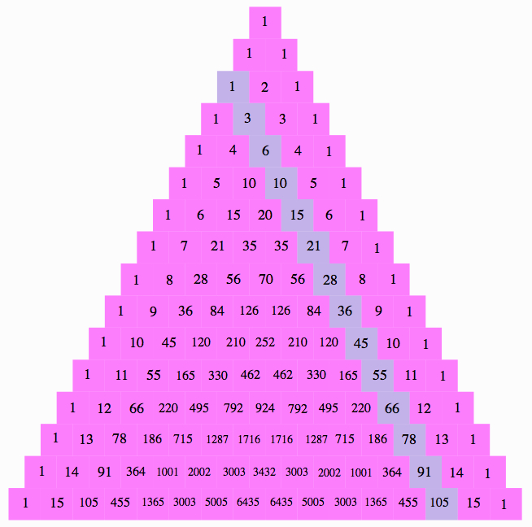
Square Numbers  Down the diagonal, as pictured to the right, are the square numbers. You can find them by summing 2 numbers together. This can be done by starting with 0+1=1=1^2 (in figure 1), then 1+3=4=2^2 (figure 2), 3+6 = 9=3^2 (in figure 1), and so on.  *Note that these are represented in 2 figures to make it easy to see the 2 numbers that are being summed. | 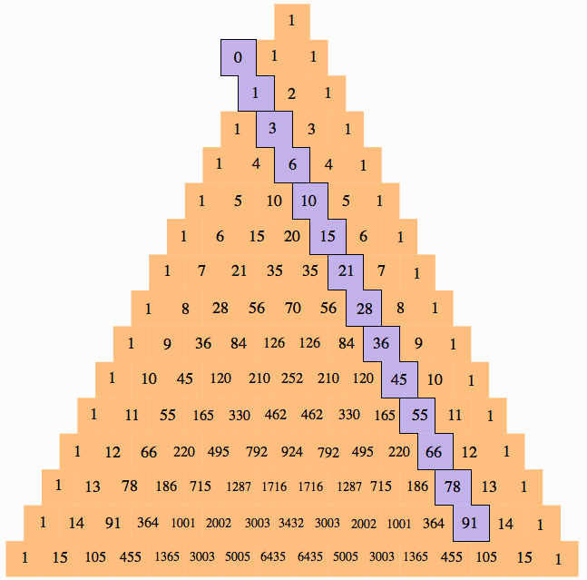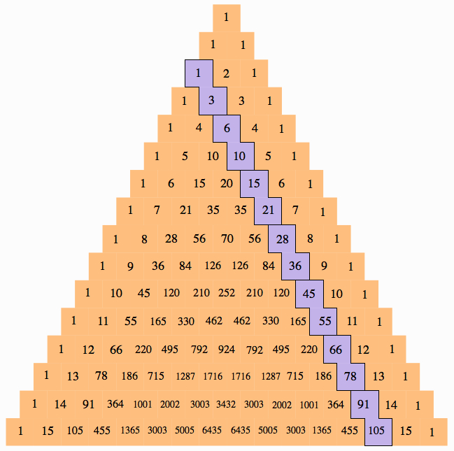
  Figure 1 | Figure 2
Fibonacci's Sequence  If you take the sum of the shallow diagonal, you will get the Fibonacci numbers. | 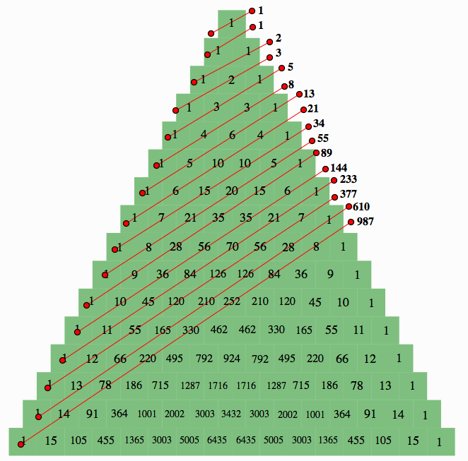
Catalan Numbers  Catalan numbers are found by taking polygons, and finding how many ways they can be partitianed into triangles. These numbers are found in Pascal's triangle by starting in the 3 row of Pascal's triangle down the middle and subtracting the number adjacent to it. | 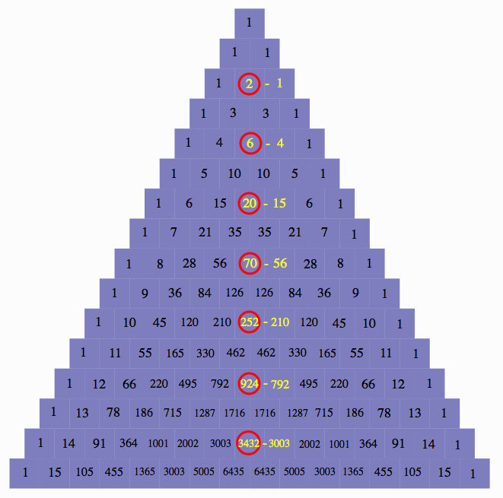
  Number of Sides | Number of Ways to Partitian
  3 | 1 | 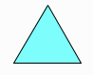
  4 | 2 | 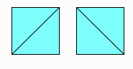
  5 | 5
  6 | 14 | 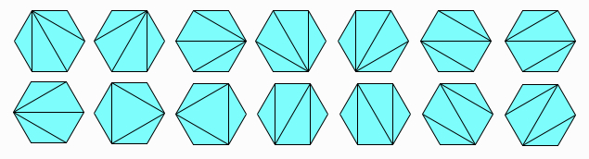
Binomial Expansion  When expanding a bionomial equation, the coeffiecents can be found in Pascal's triangle. For example, if you are expanding (x+y)^8, you would look at the 8th row to know that these digits are the coeffiencts of your answer. This is true for (x+y)^n. | 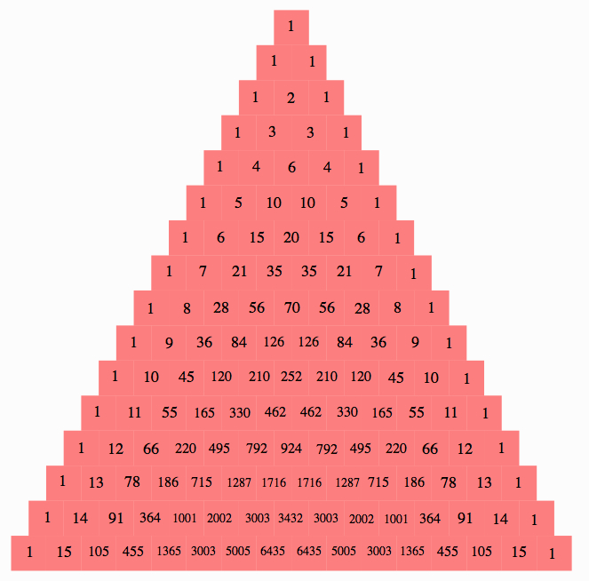
Fractal  If you shade all the even numbers, you will get a fractal. This is also the recursive of Sierpinski's Triangle. | 